**Identified code smells**

Team member number:

**Code smell 1**

Code snippet:

The exact location on the codebase:

Class FontChooser, line 112.

Explanation of the rationale for identifying this code smell:

The verification of “if(f==null)” is always false, so it will never entering on this verification and “f = myBaseFont.get()” will never be called.

A refactoring proposal:

Just remove “if( f==null)” option, and go direct do “f = f.deriveFont(absoluteSize).

**Code smell 2**

Code snippet:

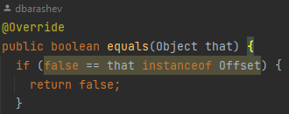

The exact location on the codebase:

Class Offset, line 87.

Explanation of the rationale for identifying this code smell:

This boolean function has a check with wasted or invalid code.

A refactoring proposal:

Replace “if (false == that instanceof Offset)” to “if(!(that instanceof Offset))”.

**Code smell 3**

Code snippet:

The exact location on the codebase:

Class OffsetBuilderImpl, line 15.

Explanation of the rationale for identifying this code smell:

The import “import biz.ganttproject.core.calendar.GPCalendar.DayType” is never been used,

Dead code.

A refactoring proposal:

Just remove the import ““import biz.ganttproject.core.calendar.GPCalendar.DayType”.